PCMH Foundation Fry Bread Taco Fundraiser – April 23, 2025
Cavalier American Legion 11:00 am-1:00 pm
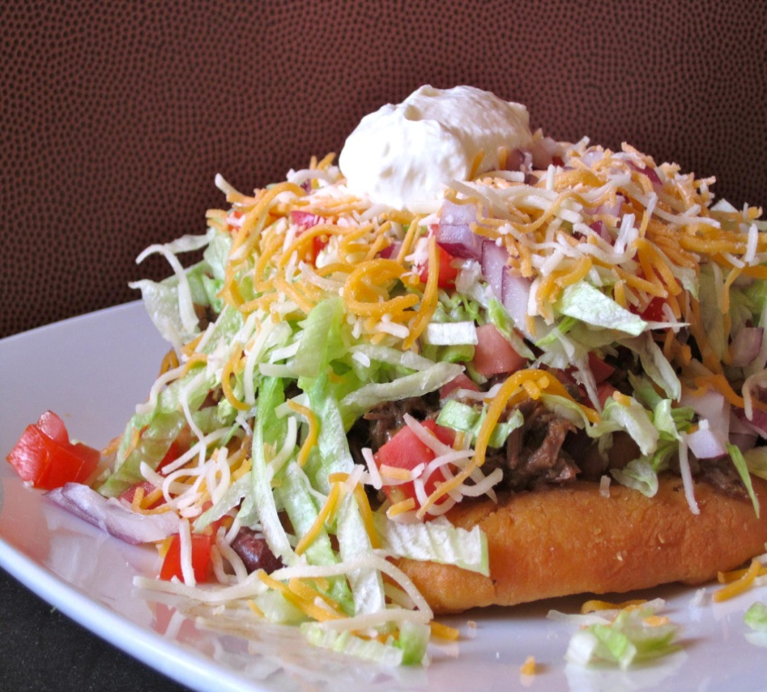
ORDER FORM FOR FRY BREAD TACO Suggested Donation: $15 Per Meal
Call 701-265-6324 or Fax 701-265-6269
Please fax or call order in by
Tuesday, April 22, at 1:00 pm. To order on
On Wed., April 23, call the Legion at 265-4606!
Pick Up or Delivery (Circle one)
NAME: _______________________
Location:______________________
Time:_________________________
Email:________________________
Telephone #:___________________

Circle Toppings: All Toppings or:
Taco Meat Lettuce Cheese Onion Tomatoes Black Olives Jalapenos
GLUTEN FREE (Chips, Meat, & Dessert)
*Sour Cream & Salsa will be included on the side
*Each taco request needs its own form
How many to this location? ____ of_____

Pick Up or Delivery (Circle one)
NAME: _______________________
Location:______________________
Time:_________________________
Email:________________________
Telephone #:___________________

Circle Toppings: All Toppings or:
Taco Meat Lettuce Cheese Onion Tomatoes Black Olives Jalapenos
GLUTEN FREE (Chips, Meat, & Dessert)
*Sour Cream & Salsa will be included on the side
*Each taco request needs its own form
How many to this location? ____ of_____

Pick Up or Delivery (Circle one)
NAME: _______________________
Location:______________________
Time:_________________________
Email:________________________
Telephone #:___________________

Circle Toppings: All Toppings or:
Taco Meat Lettuce Cheese Onion Tomatoes Black Olives Jalapenos
GLUTEN FREE (Chips, Meat, & Dessert)
*Sour Cream & Salsa will be included on the side
*Each taco request needs its own form
How many to this location? ____ of_____

Pick Up or Delivery (Circle one)
NAME: _______________________
Location:______________________
Time:_________________________
Email:________________________
Telephone #:___________________

Circle Toppings: All Toppings or:
Taco Meat Lettuce Cheese Onion Tomatoes Black Olives Jalapenos
GLUTEN FREE (Chips, Meat, & Dessert)
*Sour Cream & Salsa will be included on the side
*Each taco request needs its own form
How many to this location? ____ of_____

TOTAL NUMBER OF TACOS ORDERED FOR THIS LOCATION:_____

